
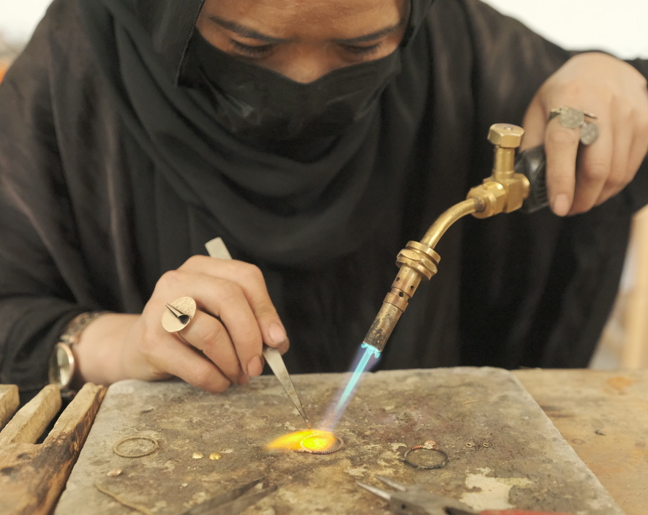

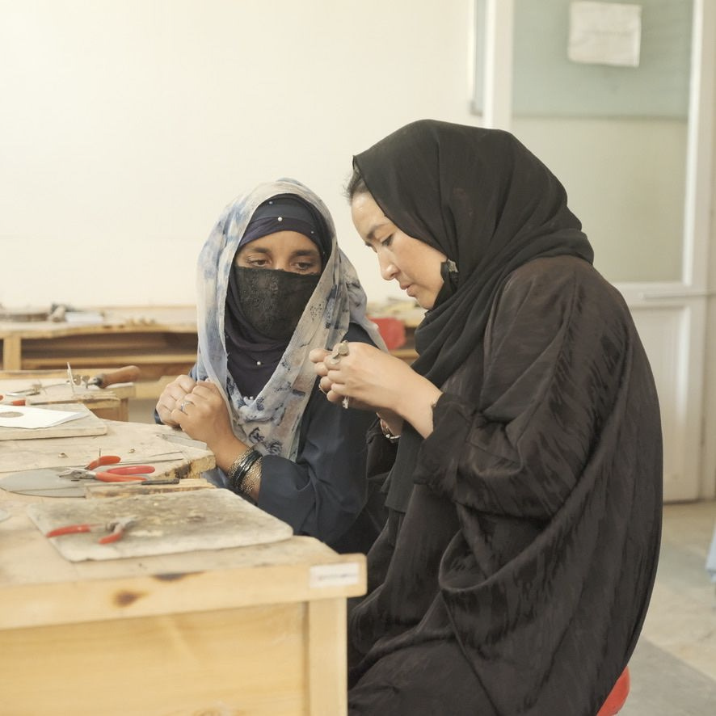
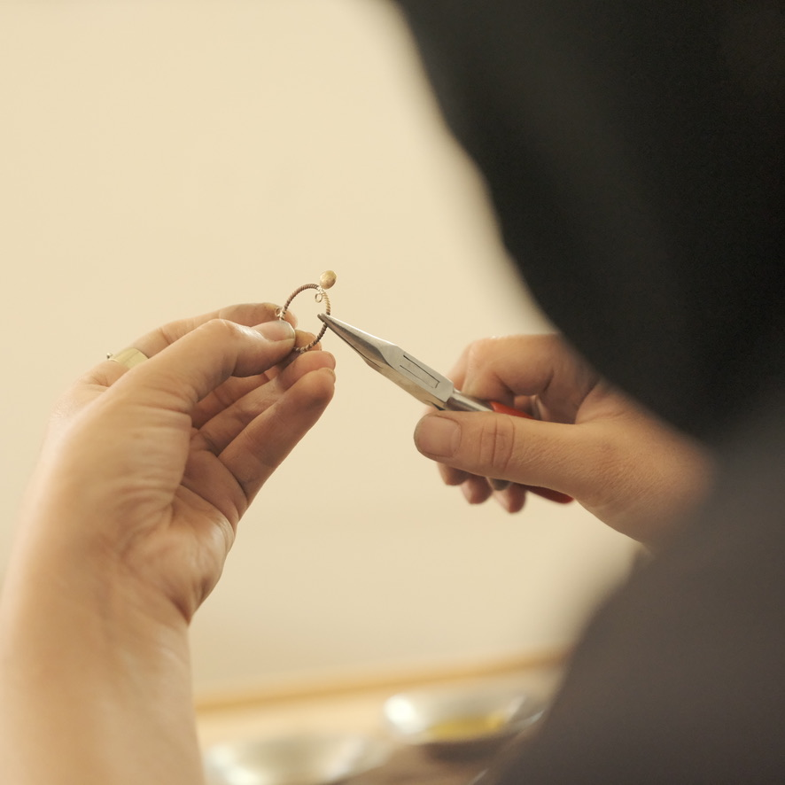
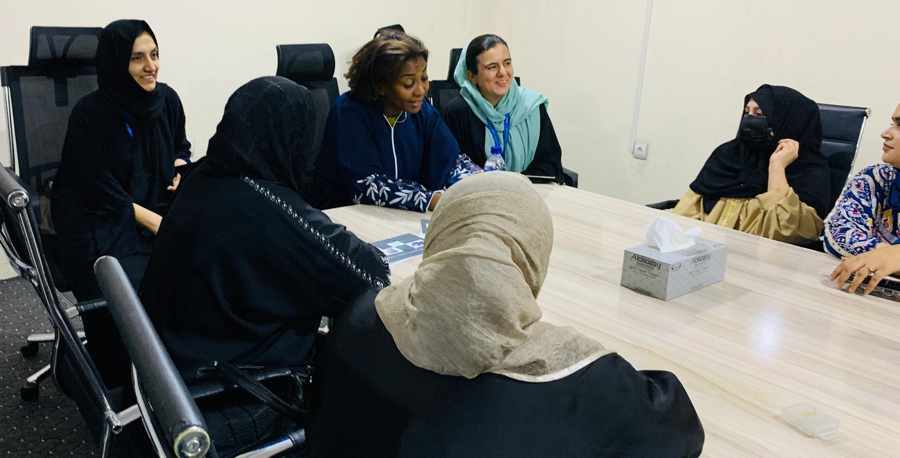
  - September 2025, Issue-1

Inside This issue
- Deputy Minister of Economy Visits RF Projects – Badakhshan
- CEO RF-a & RDI Team Attended the AVPN Global Conference 2025
- RF-a & UN-WFP Sign Agreement (FLA)

On September 11, 2025 the Rupani Foundation hosted a high-level delegation from the World Food Programme (WFP) led by Ms. Rania Dagash-Kamara, Assistant Executive Director for Partnerships and Innovation from WFP Headquarters.
During her visit, mission met with talented trainees from our Food for Training (FFT) program under the RFS project. She witnessed firsthand their skills development, reviewed their businesses, and exchanged valuable views on their journeys.
The delegation, which also included Mr. John Aylieff, Country Representative and Director of WFP Afghanistan, took a keen interest in the tangible results and positive outcomes of our joint initiative. They saw how this collaboration is empowering communities and creating sustainable livelihoods.

Ms. Dagash-Kamara deeply appreciated the incredible hard work and resilience of the women entrepreneurs and commended the impactful activities of the Rupani Foundation team on the ground.

Newsletter
RF-AFGHANISTAN

High Level mission from WFP headquarters visits Rupani foundation
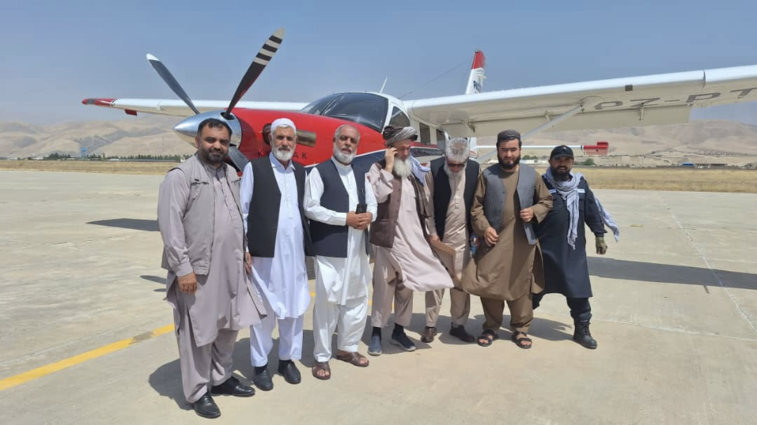
Deputy Minister of Economy Visits RF Projects – Badakhshan

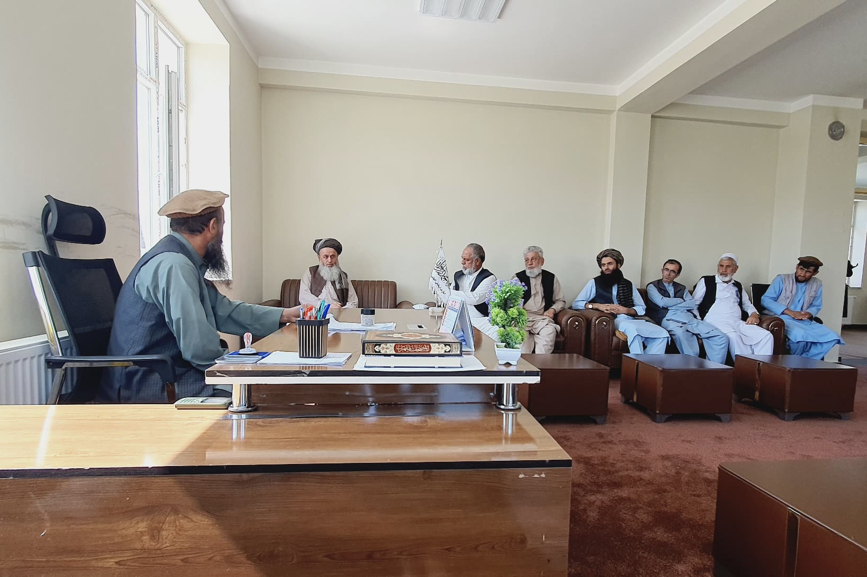
August 18–23, 2025 | Badakhshan – H.E. Mawlawi Mohammad Alam Jameel, Deputy Minister of Finance and Administration, Ministry of Economy, with Mr. Lal Mohammad Walizada, visited RF projects in Zebak, Ishkashim, and Wakhan districts of Badakhshan province. The delegation visited RF Reforestation projects, Mobile ECD centers, and agriculture infrastructure including cold storages, irrigation canals, and flood protection walls, supporting farmers and markets. Meetings were held with provincial and district officials to align on development priorities. H.E. Jameel praised RF and communities for driving sustainable development, poverty reduction,
September 2025, Issue 1
Rf-a Newsletter
and resilience in remote areas by writing an appreciation letter on his findings.
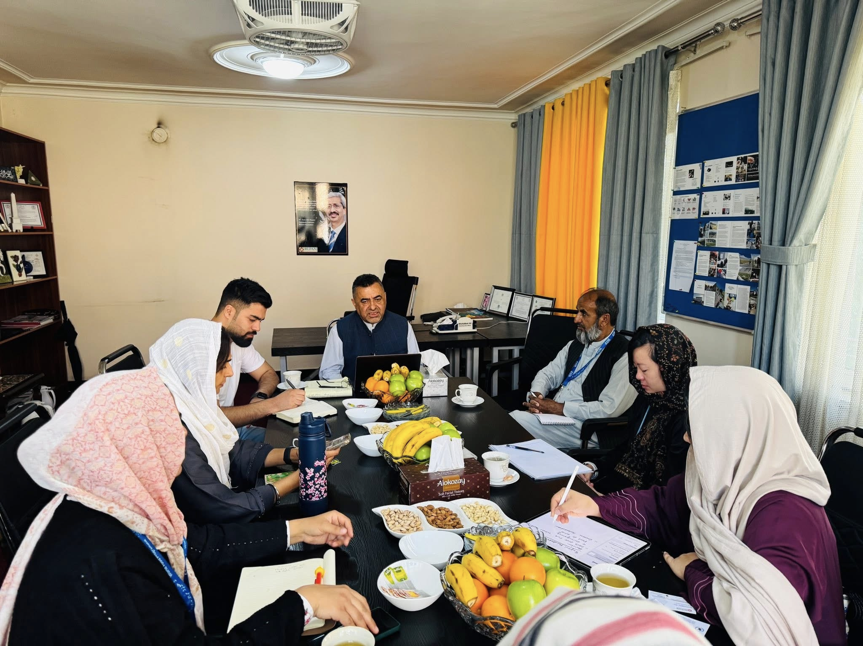
RF-a & UN-WFP Signed an Agreement on Community Resilience and Food Security project (2025-2026)

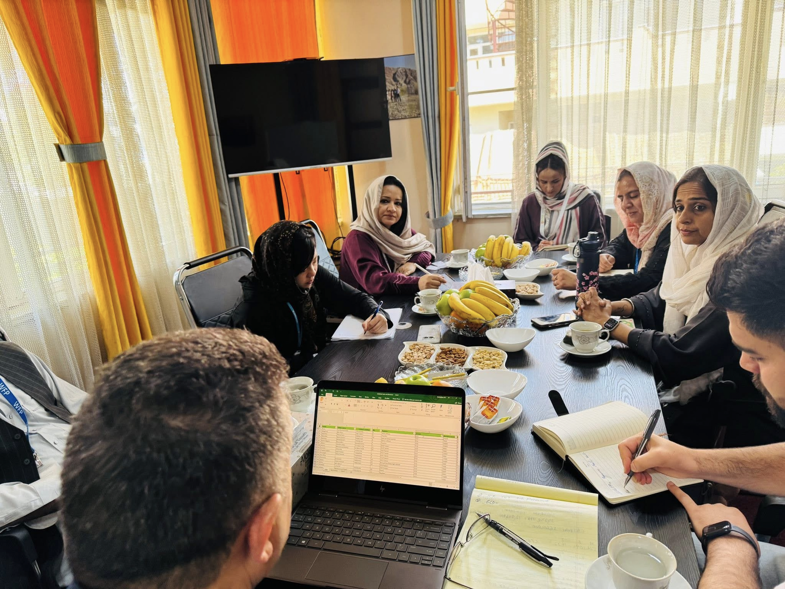
Part of the FLA signed on 1st September 2025; Rupani Foundation will implement the Vocational Skill Training program supported by the UN-WFP in all districts of Kabul. The project will include IT training in Mobile Applications & Web Development (covering 200 beneficiaries), Gemstone cutting & Jewellery making (80 beneficiaries), Handicraft (100), Renewable
Energy (70), Mushroom Cultivation (25), Agriculture Value-Addition (25), Orchard plantation & Compost making training for 350 beneficiaries, Digital Marketing & Video Editing training (100), and QuickBooks Training for (50 beneficiaries). These trainings are aimed at boosting skills, improve livelihoods, and food security for most vulnerable communities.

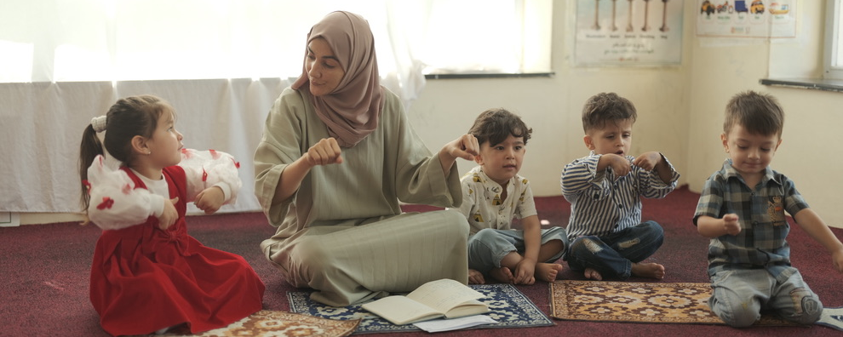
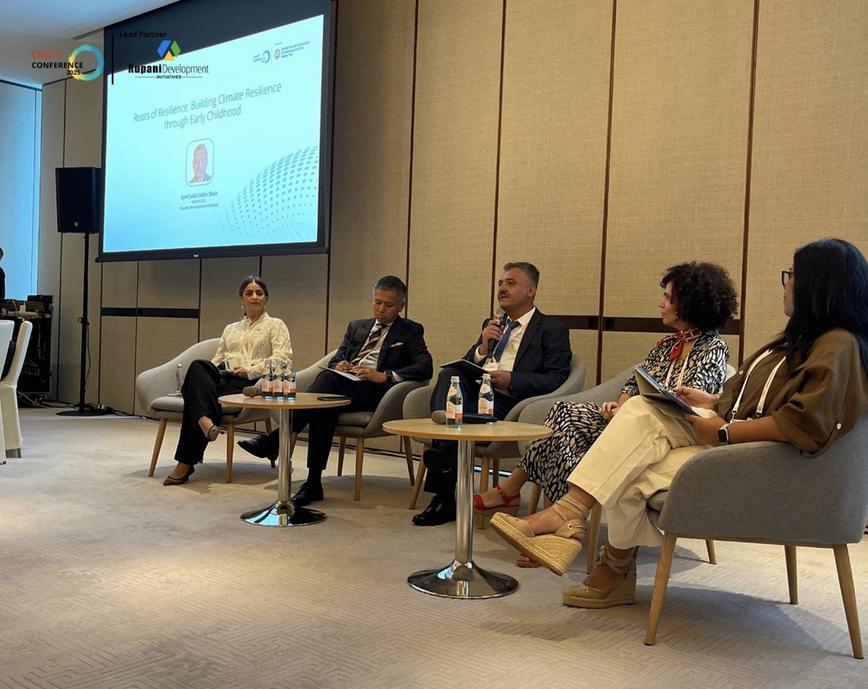

CEO RF-a & RDI Team Attended the AVPN Global Conference 2025
Rupani Development Initiative Marks Milestone Role at AVPN Global Conference 2025: Leading Conversations on Early Childhood and Climate Resilience Hongkong September 2025, Rupani Development Initiative (RDI) is making a landmark contribution at the AVPN Global Conference 2025, joining over 1,500 leaders in philanthropy, development, business, impact investing and policy. As a lead partner this year, RDI is not only sharing its two decades of experience but also shaping the agenda on one of the most urgent issues of our time: the intersection of early childhood development and climate resilience.

RDI became an AVPN member in 2023, the first and only organization representing Pakistan and Afghanistan at the network. Since then, 12 more organizations from Pakistan have joined, and AVPN has established a regional team in the country, developments that reflect RDI’s catalytic role in strengthening the region’s voice within Asia’s largest network of social investors.

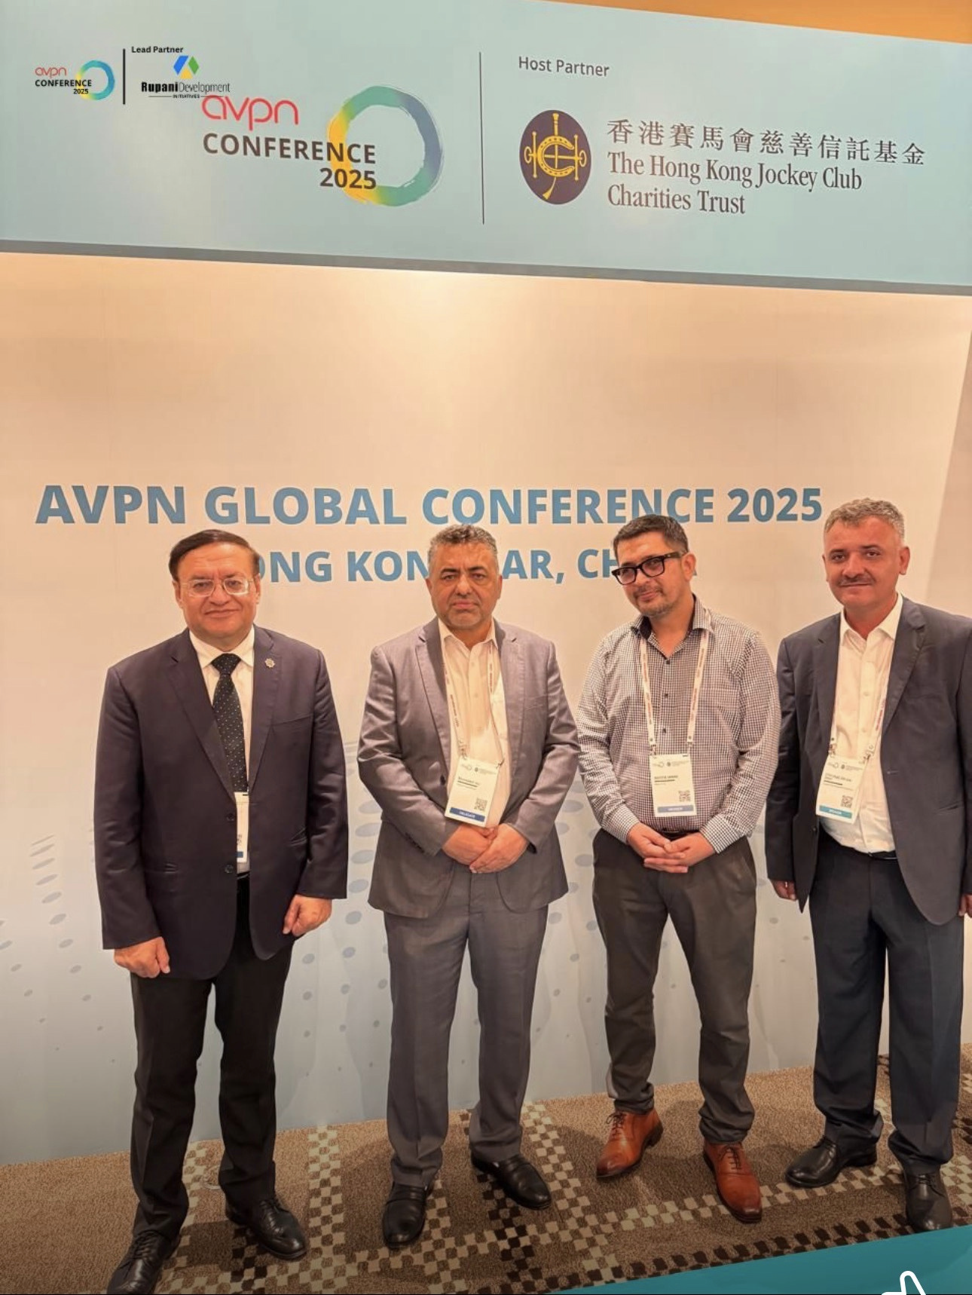

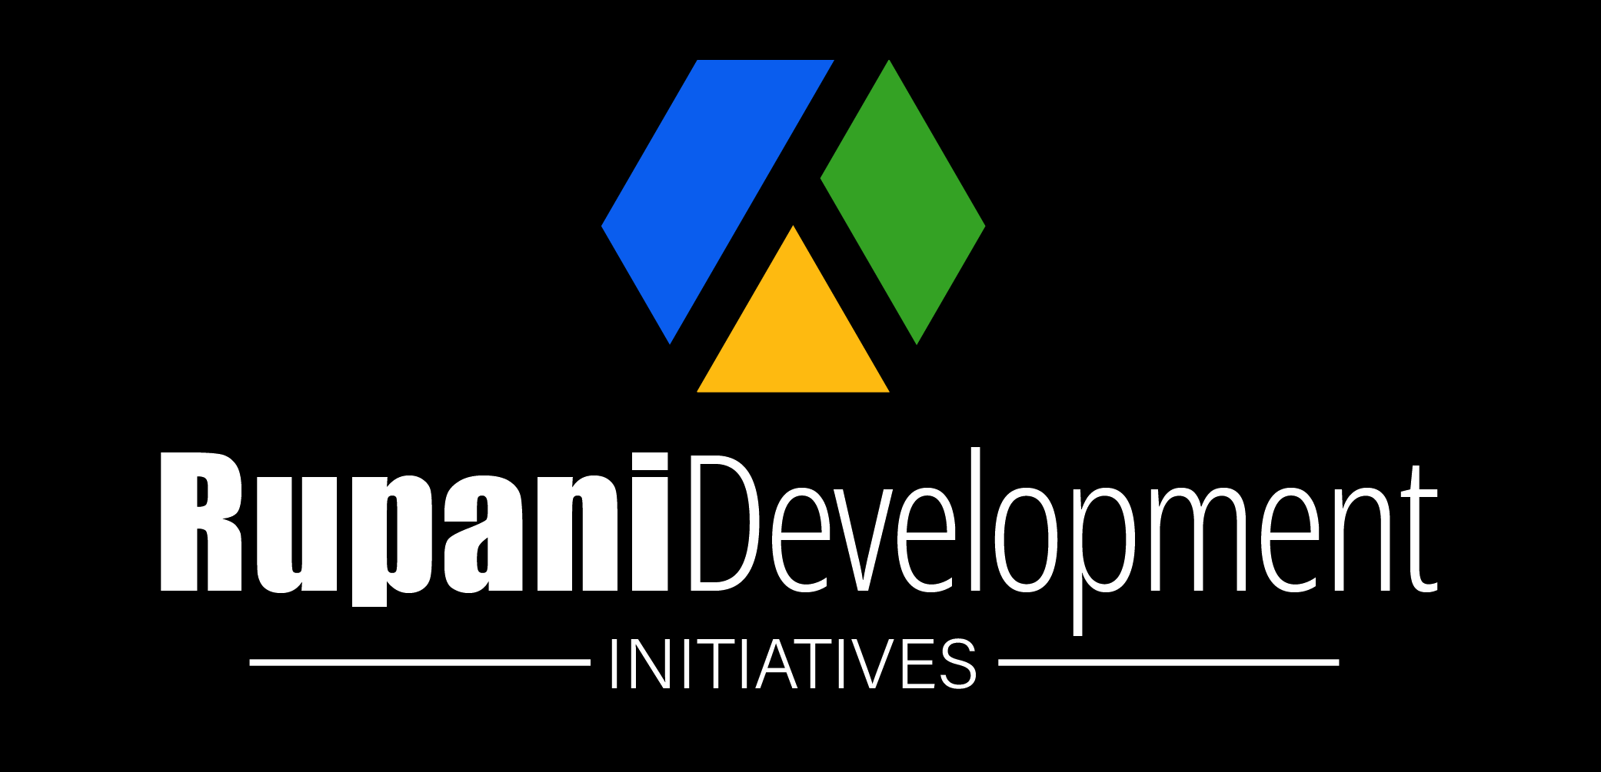

Rupani foundation-Afghanistan
Website: www.rupanifoundationafg.org
Email: info@rupanifoundationaf.org
Phone Number: +(93) 796291322
Address: House No 4. Street No 8. Qala-e Fathullah, Kabul.

September 2025, Issue 1
Rf-A Newsletter



